How to start playing Casino Inc.

1. Extract the files out of the .zip to a location of your choice (keep the files together in 1 folder).
2. Start the extracted “Casino_Inc.exe” in the root of the extracted folder.
3. When the game is started, take a look at the plot of land you’ve gotten by using the WASD keys to move, and the mouse scroll wheel to zoom in/out.
4. After you’ve taken a look at your land use the “staff” button 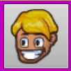 in the bottom left corner to open the staff menu.

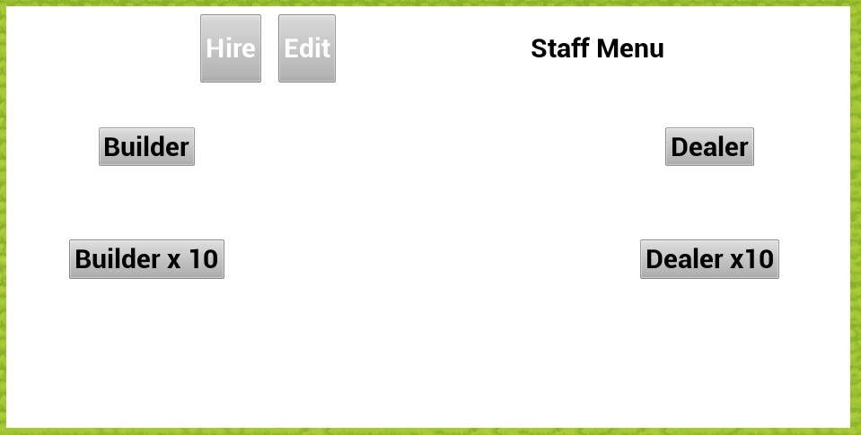

1. Hire 10 builders by either clicking the “Builder” button 10 times, or the “Builder x 10” a single time.
   1. These builders are the backbone of your casino, and will build everything for you.
2. Close the staff menu by pressing the “staff” button  again.
3. Open the Build menu by pressing the “Build” button 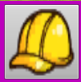.

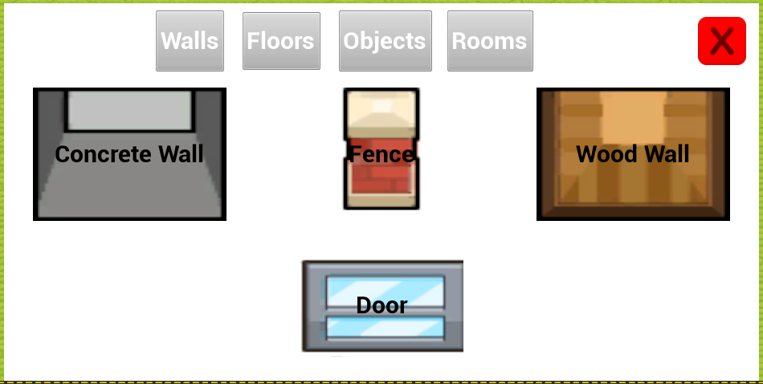

1. In this menu, use the top 4 buttons to switch between different types of buildable objects.
2. To build an object, navigate to what you want in this menu, and click the button of the object.
   1. To confirm you have selected what you want, you can check the tooltip on the right side of the screen where in blue it will show the name of the tile you have selected to be building:
   2. 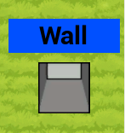
3. To close the menu, and start building, either press the “Build” button  again, or press the red cross in the building menu.
4. To build the selected object, click the item on the ground, and a task for the builders will be queued to be done, indicated by a white square.
5. For a start try to recreate the casino pictured on the next page.
   1. This should give you things to let guests come in.
   2. The advised order to build this in is first the walls and floor, followed by the games.

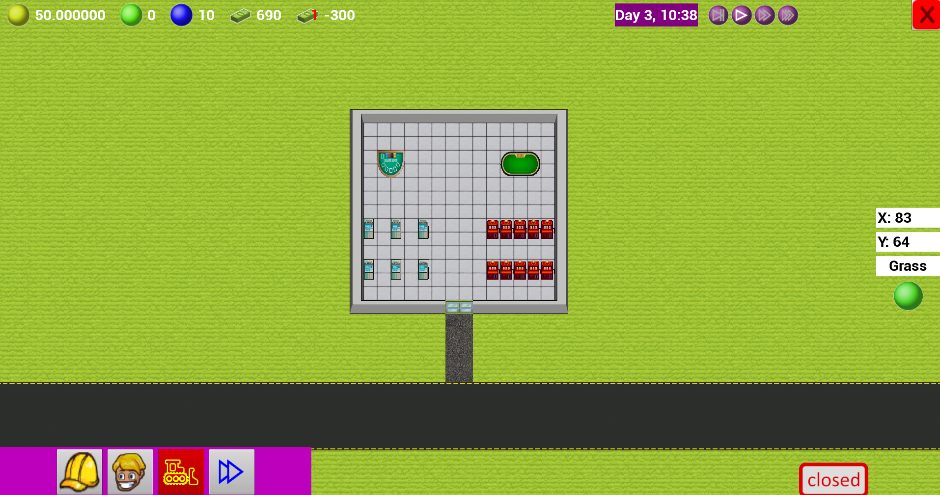

1. While waiting for your builders to build this, hire 6 dealers by clicking the “staff” button  and pressing the button with “dealer” 6 times.
2. In the staff menu, press the “Edit” button  to open up the work times editor.
3. In this menu, scroll down to the “Dealer” entries.

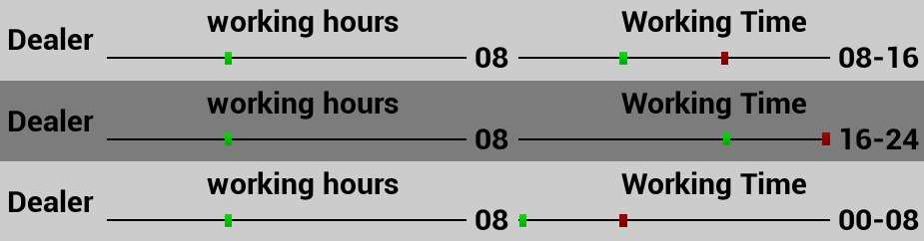

1. For these dealer entries, move 2 of the “working time” sliders to note “16-24” and 2 to show “00-08” using the green notch.
   1. This makes sure you always have 2 dealers in your casino to work on the poker and blackjack tables for the guests to use them.
2. Close the staff menu by pressing the “staff” button  again.
3. When your builders are done building the casino, press the “open/close” button 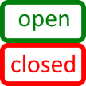 in the bottom right corner to open your casino for guests.
4. Now your money will slowly start going up again, and you’re free to upgrade your casino however you want from here.

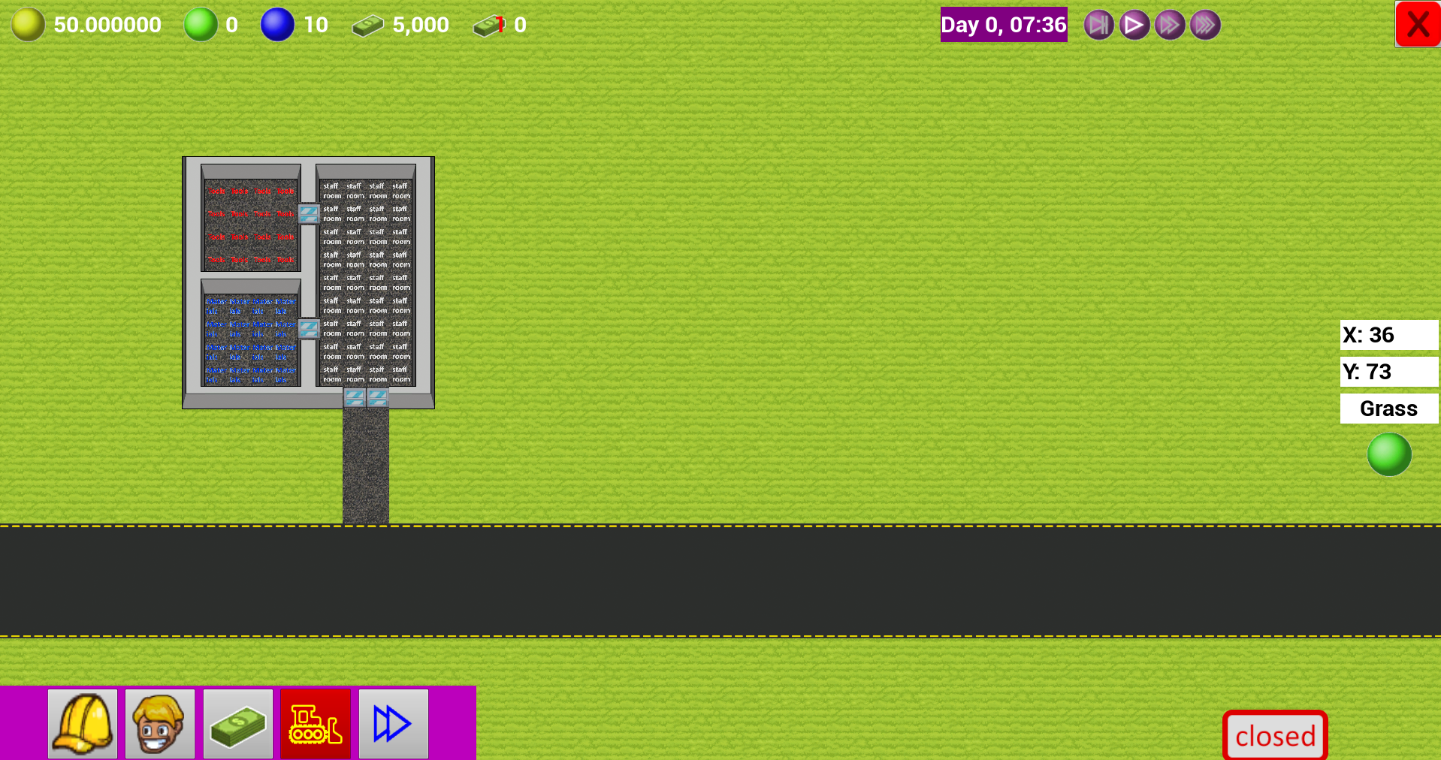

# GUI:

Top left corner (left to right):

1. Yellow dot: 
   1. average happiness for the casino, influenced by the happiness of the guests, decides how often new guests spawn
2. green dot: 
   1. Guest count, the current amount of guests in the casino.
3. Blue dot: 
   1. Staff count, the amount of staff that you have.
4. Cash stack: 
   1. The amount of money you have
5. Cash stack with small 1: 
   1. The amount of money you have spent/earned during the current in game day.

Top Right corner (left to right):

1. Timer: 
   1. Current in game time.
2. Speed buttons: 
   1. Changes the game speed to the following choices:
      1. 0.5x speed (in game day takes 40 minutes)
      2. Normal speed (in game day takes 20 minutes)
      3. 2x speed (in game day takes 10 minutes)
      4. Super speed (in game day takes 5 minutes)

Bottom Left Corner (left to right):

1. Build Menu: 
   1. Opens up the build menu explained in “how to” steps 6 till 10
2. Staff menu: 
   1. Opens up the staff menu, explained in steps 3 till 5 and 12 till 16
3. Destroy button: 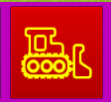
   1. Used to destroy objects when placed wrongly.
   2. When pressed you can select objects to be marked for destroy by the builders.
   3. On the far-right side of the screen a red “Destroying” tooltip will show up indicating you’re in destroy mode.
4. Priority button: 
   1. Used to prioritize tasks.
   2. When you want something to be build quicker by the builders, you can use this button to mark tasks as priority, and it will be put in a different task queue to be done before the other tasks.

Right side (top to bottom):

1. Stop button: 
   1. Quits the game
2. X coordinate: 
   1. The X coordinate that your mouse pointer is hovering over.
3. Y coordinate: 
   1. The Y coordinate that your mouse pointer is hovering over.
4. Tile type: 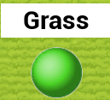
   1. The type and a preview of the tile your mouse pointer is hovering over.
5. Mode indicator:   
   1. A indicator for what mode you’re currently in, could be one of:
      1. Building: shows the type of object you have selected to build
      2. Destroying: shows that you’re marking objects for destroy
      3. Priority: shows that you’re marking tasks to be prioritized
6. Open/close button: 
   1. Switches the casino between open/closed, when closed the casino does not attract new guests.